Application Based Questions
CO2 AT2
MLA0303 – Reinforcement Learning
Submitted by

M Yasodha Krishna (192472100)
Under the Supervision of

Dr. Dumpala Prasanth

QUESTIONS: 10 Total Marks: 50

Annexure A
Application - Based Questions
Duration: 2Hrs

1. Design and develop a Reinforcement Learning framework a ride-sharing company uses Reinforcement Learning to match drivers with passengers efficiently. Apply RL concepts to define the state space, action space, and reward function to minimize waiting time and improve service quality. (5 Marks)
ANSWER:

1. Understanding of the Problem
A ride-sharing company wants to match drivers with passengers quickly to reduce waiting time and improve customer satisfaction.

2. Application of RL Concepts
State Space
- Driver location
- Passenger location
- Traffic condition
- Available drivers
Action Space
- Assign nearest driver
- Reassign another driver
- Wait for a better match
Reward Function
- Positive reward for quick pickup and successful ride
- Negative reward for delays and cancellations

3. Problem-Solving Approach
The RL agent observes the current state, selects the best driver, receives rewards based on service quality, and updates its policy through continuous learning.

4. Solution/Outcome
- Reduced waiting time
- Better driver utilization
- Improved customer satisfaction

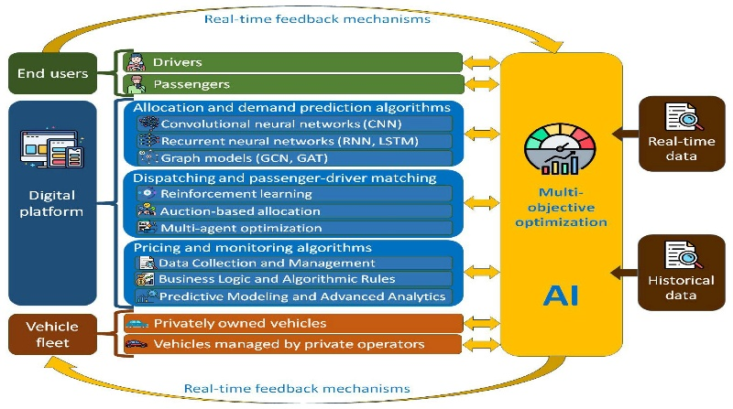

2. An e-learning platform uses Reinforcement Learning to recommend personalized study materials. Recall how exploration and exploitation strategies help balance familiar and new content recommendations. (5 Marks)
ANSWER:

1. Understanding of the Problem
A ride-sharing company wants to match drivers with passengers quickly to reduce waiting time and improve customer satisfaction.

2. Application of RL Concepts
State Space

Driver location
Passenger location
Traffic condition
Available drivers
Action Space
Assign nearest driver
Reassign another driver
Wait for a better match
Reward Function
Positive reward for quick pickup and successful ride
Negative reward for delays and cancellations

3. Problem-Solving Approach
The RL agent observes the current state, selects the best driver, receives rewards based on service quality, and updates its policy through continuous learning.

4. Solution/Outcome

Reduced waiting time
Better driver utilization
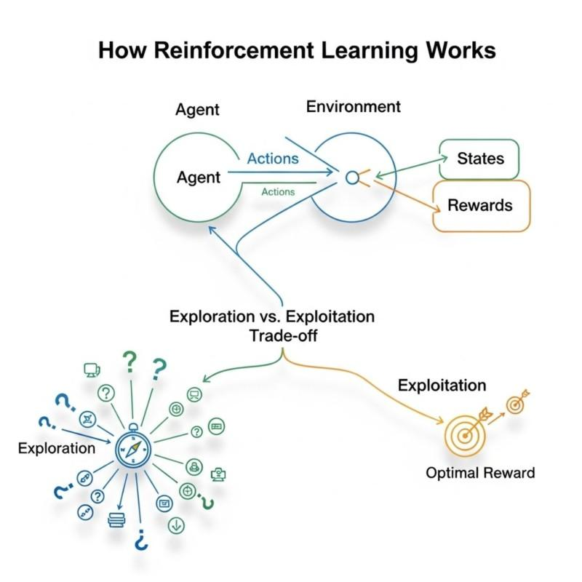
Improved customer satisfaction

3. Design and develop a Reinforcement Learning framework a robotic vacuum cleaner uses Reinforcement Learning to clean efficiently while avoiding obstacles. Apply the concept of policy and explain how the value function improves performance over time.
(5 Marks)

ANSWER:

1. Understanding of the Problem)
The robot must clean efficiently while avoiding obstacles.
2. Application of RL Concepts
Policy
- Selects the next movement
- Avoids obstacles
Value Function
- Estimates future rewards
- Chooses efficient cleaning paths
3. Problem-Solving Approach
The robot learns from experience by receiving rewards for efficient cleaning and penalties for collisions.
4. Solution/Outcome
- Faster cleaning
- Better obstacle avoidance
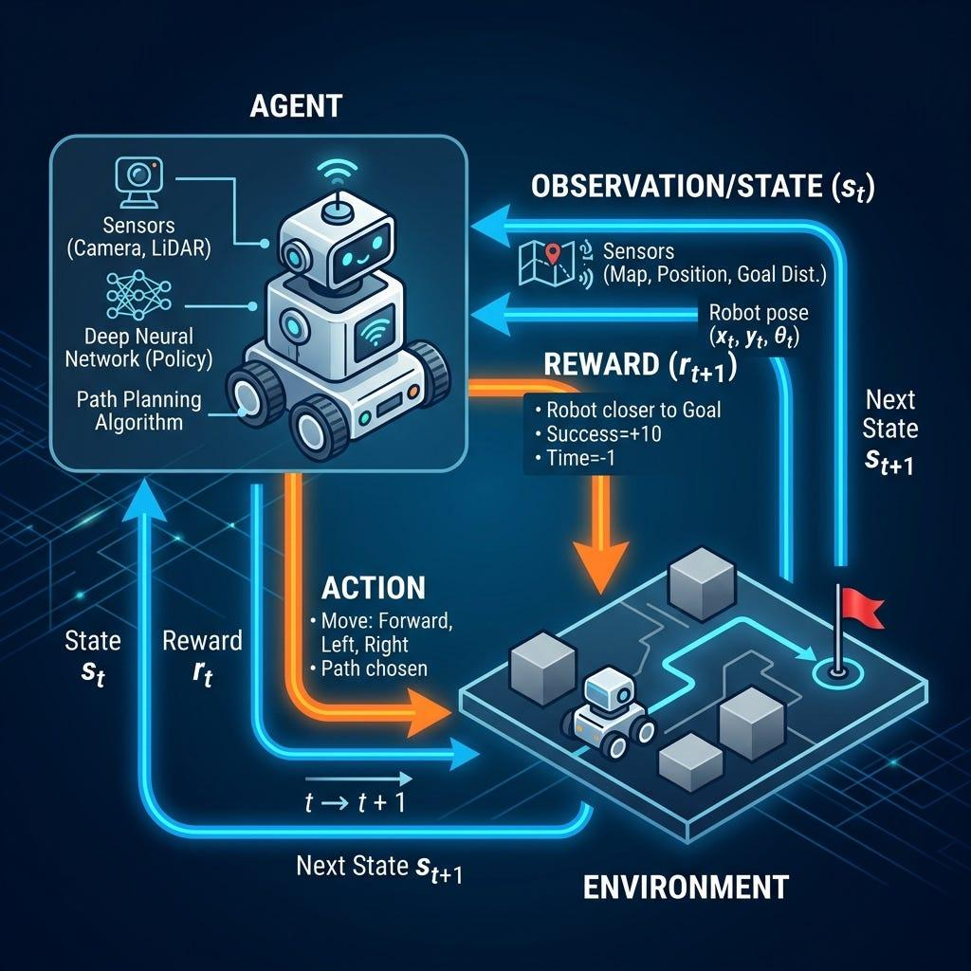
- Reduced battery usage

4. A cryptocurrency trading system uses Reinforcement Learning to decide buy, sell, or hold actions. Outline the challenges in designing reward functions and explain how poor reward design can affect performance. (5 Marks)
ANSWER:

1. Understanding of the Problem
The trading system decides when to buy, sell, or hold cryptocurrencies.
2. Application of RL Concepts
Reward Challenges
- Price volatility
- Delayed profits
- Market uncertainty
3. Problem-Solving Approach
The RL agent updates its trading strategy using rewards based on long-term profit.
4. Solution/Outcome
- Better trading decisions
- Reduced financial loss
- Improved profitability
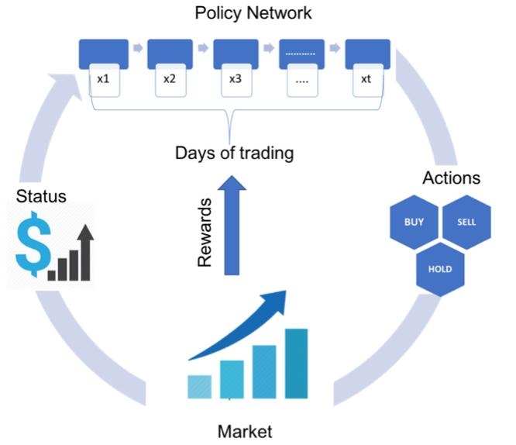

5. Develop a smart grid system uses Reinforcement Learning to manage electricity distribution. Create an RL model by defining state space, action space, and reward mechanism.
(5 Marks)
ANSWER:

1. Understanding of the Problem
The smart grid manages electricity distribution efficiently.
2. Application of RL Concepts
State Space
- Electricity demand
- Power generation
- Battery level
Action Space
- Increase supply
- Reduce supply
- Store energy
Reward Function
- Positive reward for balanced distribution
- Negative reward for power loss
3. Problem-Solving Approach
The RL agent continuously monitors demand and adjusts power distribution.
4. Solution/Outcome
- Reliable electricity supply
- Lower energy wastage
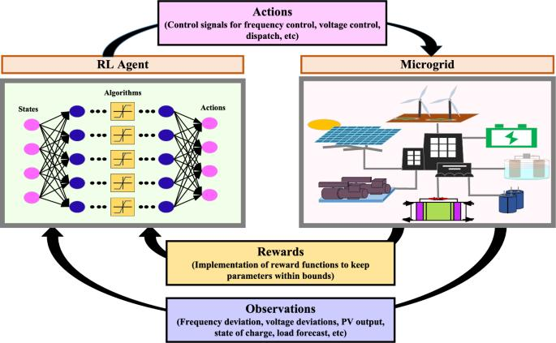
- Reduced operating cost

6. A healthcare monitoring system uses Reinforcement Learning to adjust medication dosages. Apply RL concepts to define states, actions, and rewards, and explain how learning improves outcomes. (5 Marks)
ANSWER:

1. Understanding of the Problem
The system adjusts medication dosage according to the patient's health.
2. Application of RL Concepts
States
- Patient condition
- Blood pressure
- Heart rate
Actions
- Increase dosage
- Reduce dosage
- Maintain dosage
Rewards
- Positive reward for health improvement
- Negative reward for side effects
3. Problem-Solving Approach
The RL agent learns the optimal dosage by analyzing patient responses.
4. Solution/Outcome
- Personalized treatment
- Better recovery
- Fewer health risks
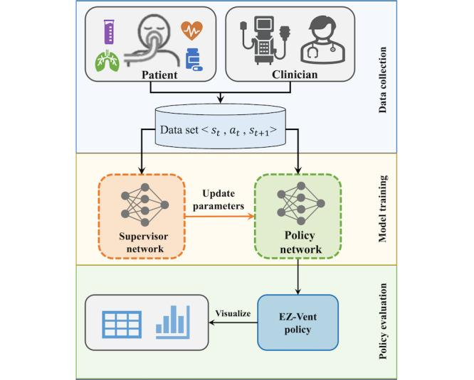

7. Design a model drone delivery system uses Reinforcement Learning for navigation. Recall how exploration and exploitation strategies influence route optimization.
(5 Marks)
ANSWER:

1. Understanding of the Problem
The drone must deliver packages using the best route.
2. Application of RL Concepts
Exploration
- Tries new routes
Exploitation
- Uses successful routes
3. Problem-Solving Approach
The RL agent balances exploration and exploitation to find optimal routes.
4. Solution/Outcome
- Faster deliveries
- Reduced battery consumption
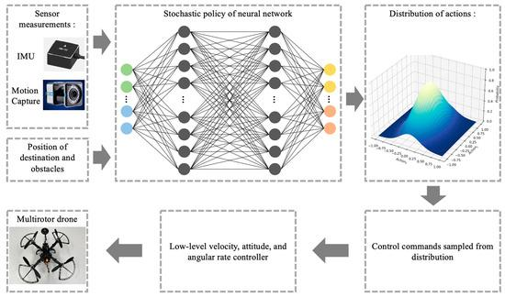
- Better route optimization

8. Design and develop a Reinforcement Learning framework a manufacturing robot uses Reinforcement Learning to optimize assembly operations. Apply the concept of policy and explain how value functions help improve efficiency.
(5 Marks)
ANSWER:

1. Understanding of the Problem
The robot performs assembly operations efficiently.
2. Application of RL Concepts
Policy
- Chooses assembly actions
Value Function
- Estimates long-term rewards
3. Problem-Solving Approach
The RL agent improves its policy based on rewards from successful assembly operations.
4. Solution/Outcome
- Faster production
- Fewer errors
- Higher product quali
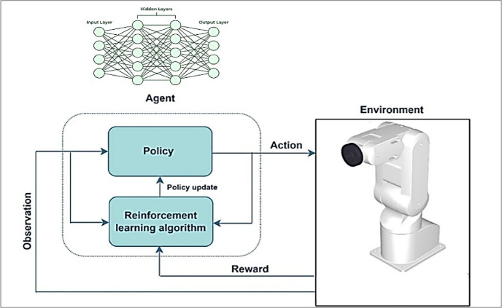

9. An online advertising system uses Reinforcement Learning to maximize click-through rates. Outline reward design challenges and explain their impact on system performance. (5 Marks)
ANSWER:

1. Understanding of the Problem
The system aims to maximize advertisement click-through rates.
2. Application of RL Concepts
Reward Challenges
- Delayed clicks
- Fake clicks
- Changing user preferences
3. Problem-Solving Approach
The RL agent updates advertisement selection using user interaction rewards.
4. Solution/Outcome
- Higher click-through rate
- Better ad targeting
- Increased revenue
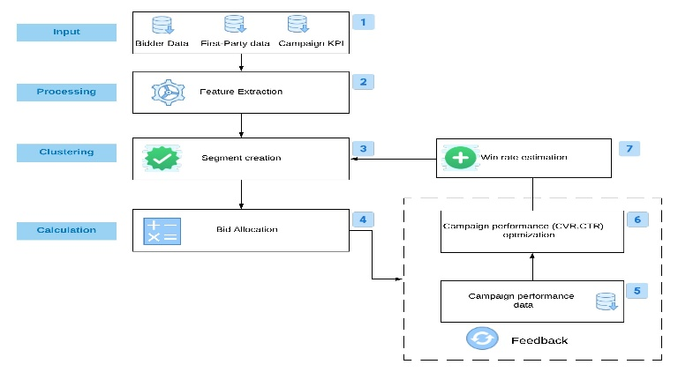

10. A smart irrigation system uses Reinforcement Learning to optimize water usage. Create an RL framework by defining states, actions, and reward function. (5 Marks)

ANSWER:

1. Understanding of the Problem
The irrigation system supplies the right amount of water to crops.
2. Application of RL Concepts
State Space
- Soil moisture
- Weather
- Temperature
Action Space
- Start irrigation
- Stop irrigation
- Adjust water flow
Reward Function
- Positive reward for saving water
- Negative reward for overwatering
3. Problem-Solving Approach
The RL agent learns the best irrigation schedule from environmental feedback.
4. Solution/Outcome
- Efficient water usage
- Better crop growth
- Sustainable farming
